Nocturne
and Minuet
for String Orchestra
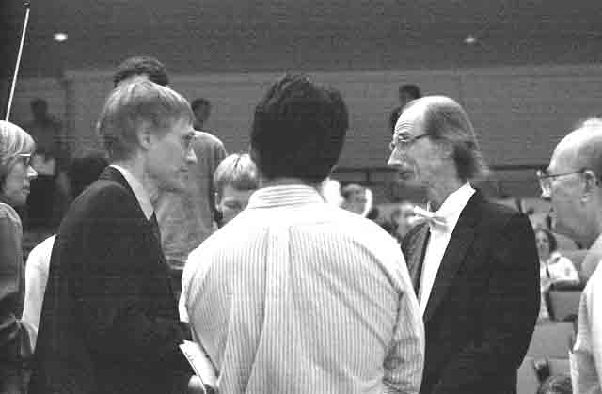
Violin II

Bill Robinson

