STRANGE SONGS

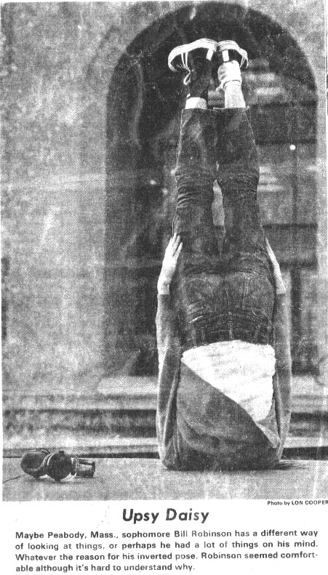

for Baritone,

SATB Chorus,

and Piano Quintet

Bill Robinson