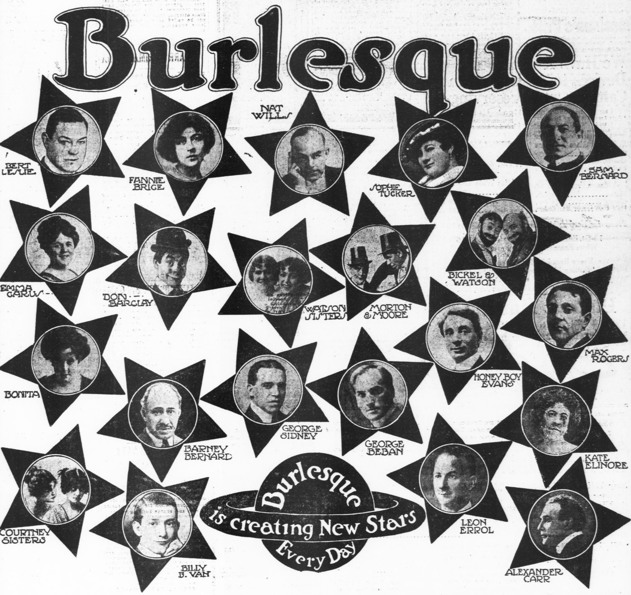

### for Concert Band

Bill Robinson