### Burlesque

### for Concert Band

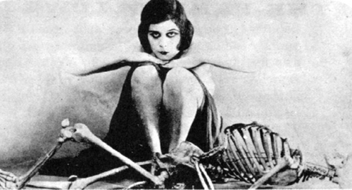

Bill Robinson