### Burlesque

### for Concert Band

Piccolo

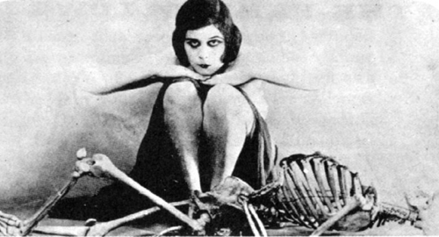

Bill Robinson