### Burlesque

### for Concert Band

Flute 1

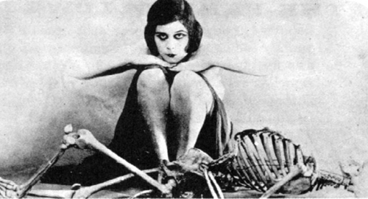

Bill Robinson