### Burlesque

### for Concert Band

Flute 2

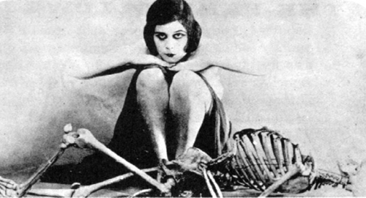

Bill Robinson