### Burlesque

### for Concert Band

Oboe 2

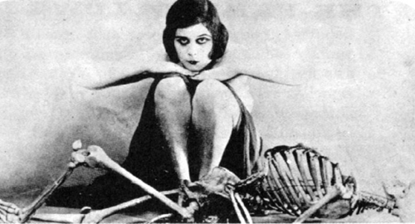

Bill Robinson