### Burlesque

### for Concert Band

Bassoon 1

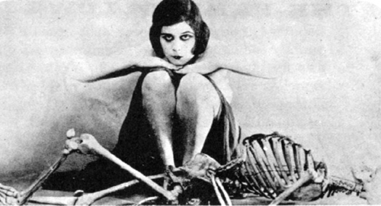

Bill Robinson