### Burlesque

### for Concert Band

Clarinet 1in B Flat

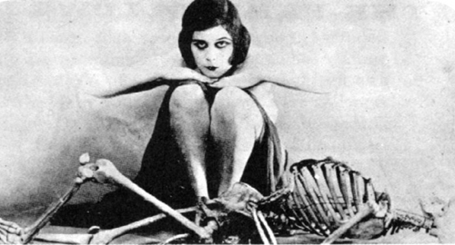

Bill Robinson