### Burlesque

### for Concert Band

Clarinet 2 in B Flat

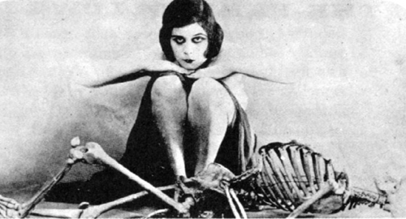

Bill Robinson