### Burlesque

### for Concert Band

Clarinet 3 in B Flat

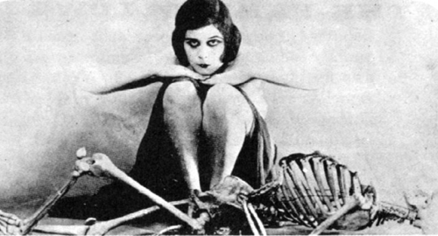

Bill Robinson