### Burlesque

### for Concert Band

Bass Clarinet

in B Flat

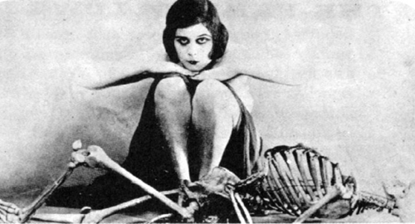

Bill Robinson