### Burlesque

### for Concert Band

Alto Saxophone 1

in E Flat

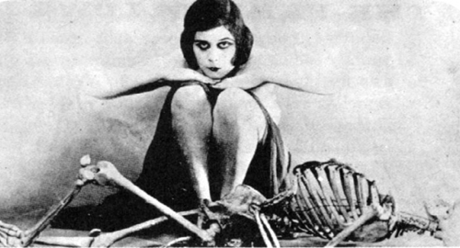

Bill Robinson