### Burlesque

### for Concert Band

Alto Saxophone 2

in E Flat

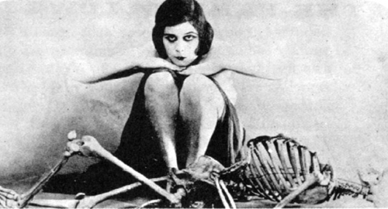

Bill Robinson