### Burlesque

### for Concert Band

Baritone Saxophone

in B Flat

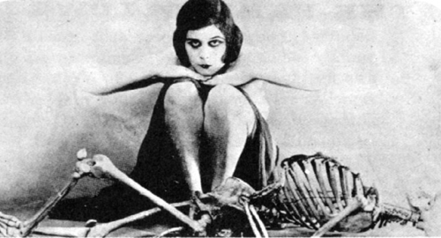

Bill Robinson