### Burlesque

### for Concert Band

Trumpet 1in B Flat

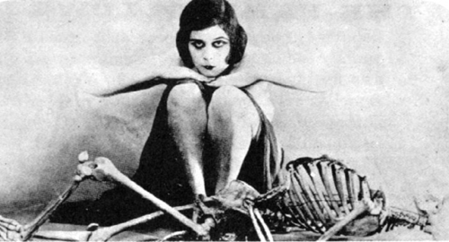

Bill Robinson