### Burlesque

### for Concert Band

Trumpet 2 in B Flat

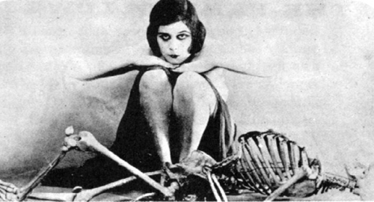

Bill Robinson