### Burlesque

### for Concert Band

Trombone 1

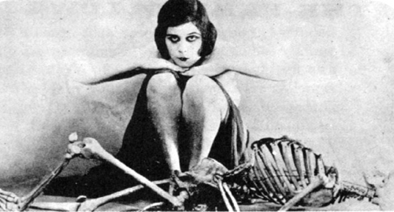

Bill Robinson