### Burlesque

### for Concert Band

Trombone 2

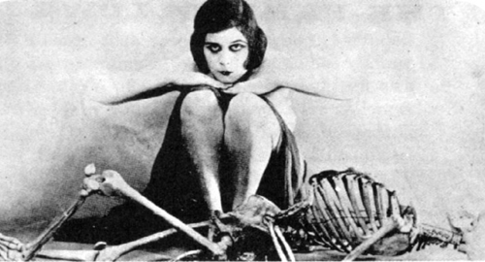

Bill Robinson