### Burlesque

### for Concert Band

Bass Trombone

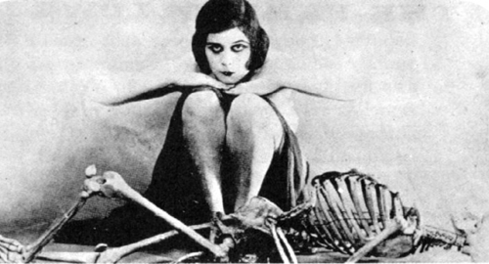

Bill Robinson