### Burlesque

### for Concert Band

Euphonium

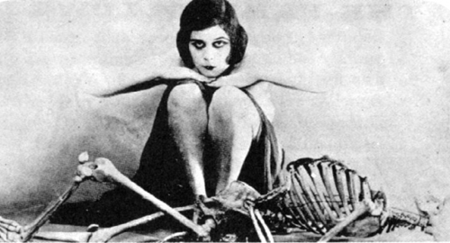

Bill Robinson