### Burlesque

### for Concert Band

Tuba 1

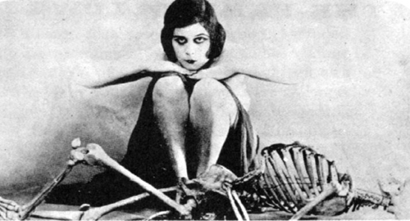

Bill Robinson