### Burlesque

### for Concert Band

Tuba 2

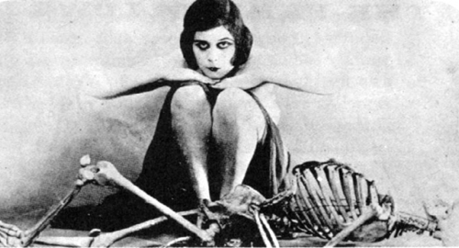

Bill Robinson