For Those Who Fell:

A War Memorial

for

Concert Band

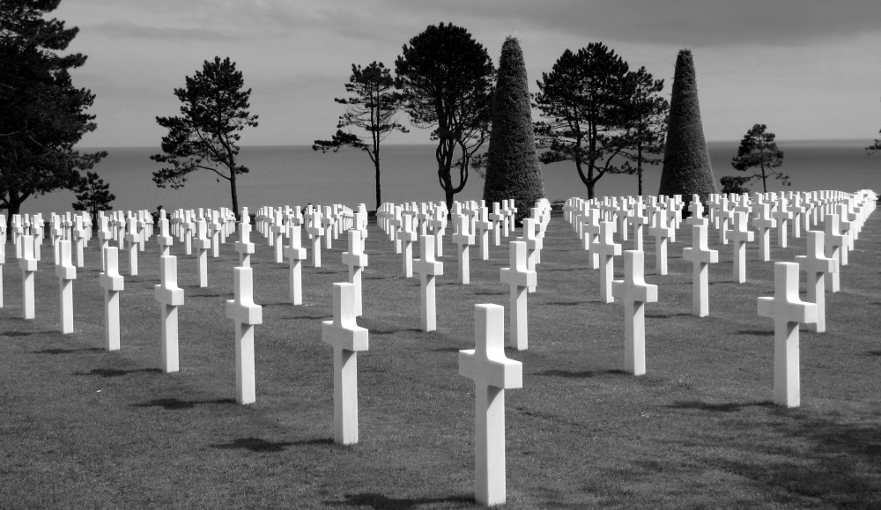

Bill Robinson