### Miniatures

### for Woodwind Quintet and Piano

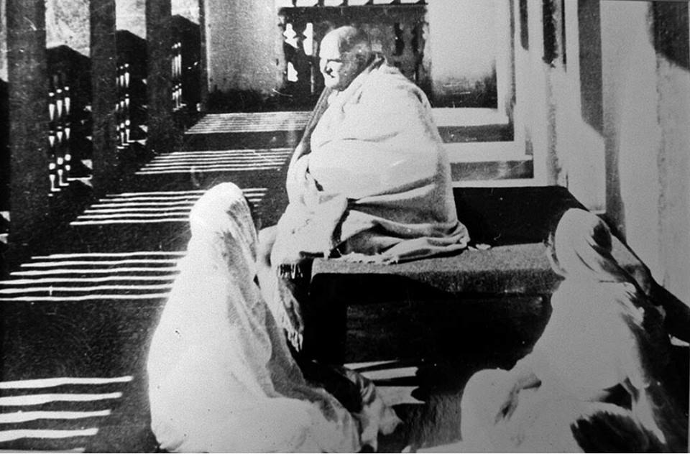

Bill Robinson