### Polytonalmodalyodel

### for Concert Band

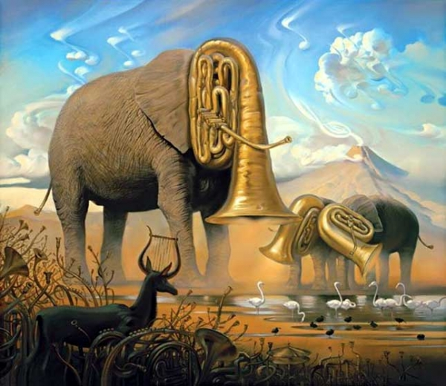

Bill Robinson