### Polytonalmodalyodel

### for Concert Band

Piccolo

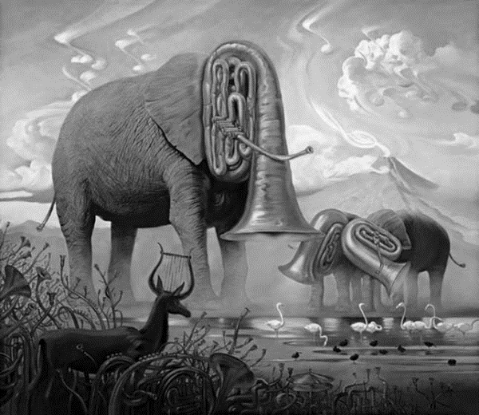

Bill Robinson