### Polytonalmodalyodel

### for Concert Band

Oboe 1

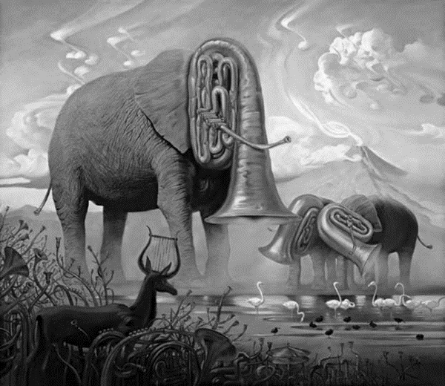

Bill Robinson