### Polytonalmodalyodel

### for Concert Band

Bassoon 1

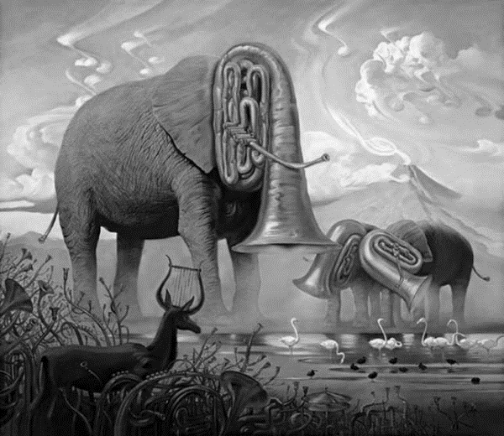

Bill Robinson