### Polytonalmodalyodel

### for Concert Band

Bassoon 2

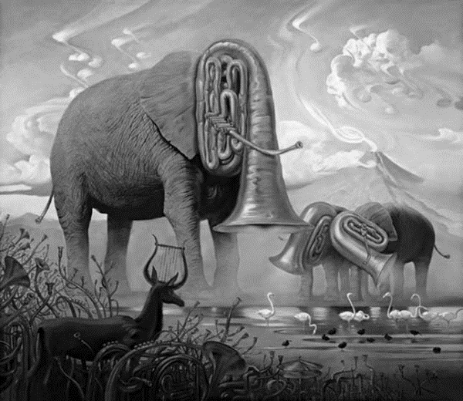

Bill Robinson