### Polytonalmodalyodel

### for Concert Band

Clarinet 1

in B flat

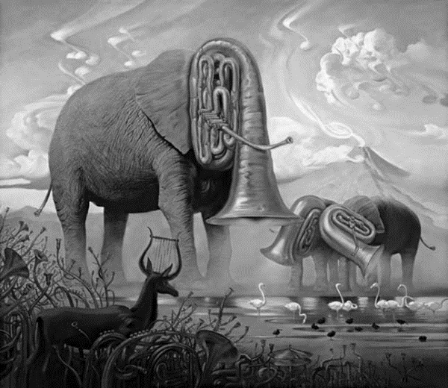

Bill Robinson