### Polytonalmodalyodel

### for Concert Band

Clarinet 2

in B flat

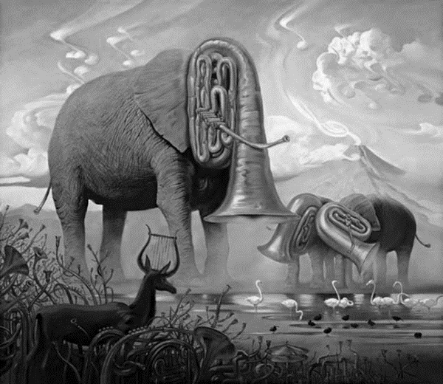

Bill Robinson