### Polytonalmodalyodel

### for Concert Band

Baritone Saxophone

in E flat

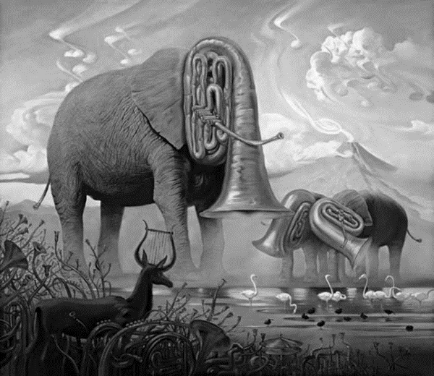

Bill Robinson