### Polytonalmodalyodel

### for Concert Band

Trumpet 1

in B Flat

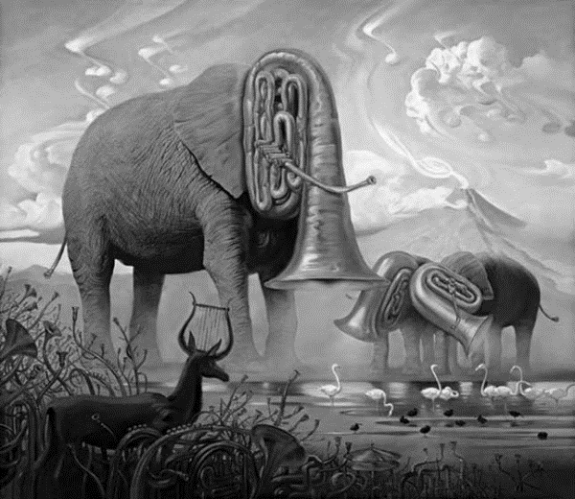

Bill Robinson