### Polytonalmodalyodel

### for Concert Band

Trumpet 2

in B Flat

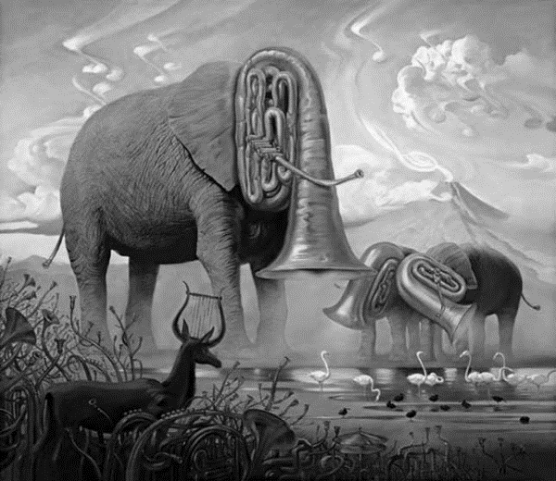

Bill Robinson