### Polytonalmodalyodel

### for Concert Band

Trombone 1

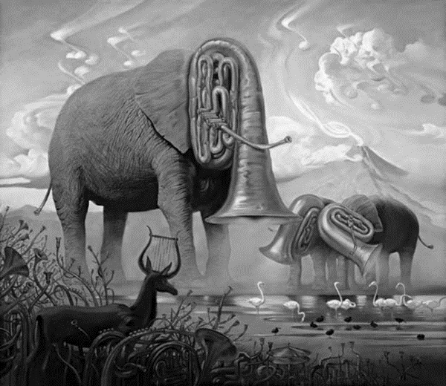

Bill Robinson