### Polytonalmodalyodel

### for Concert Band

Trombone 2

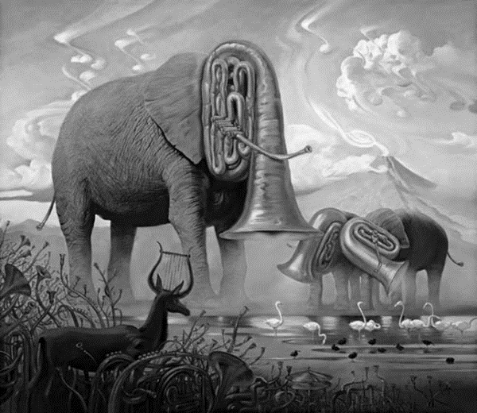

Bill Robinson