### Polytonalmodalyodel

### for Concert Band

Euphonium

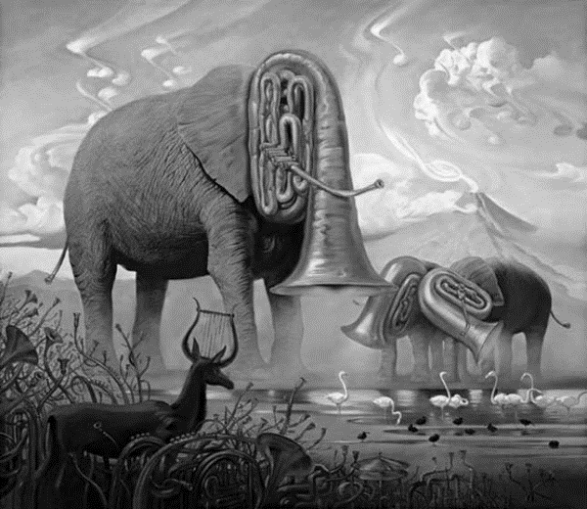

Bill Robinson