### Polytonalmodalyodel

### for Concert Band

Tuba 1

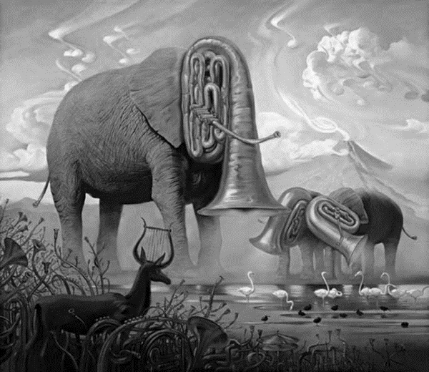

Bill Robinson