### Polytonalmodalyodel

### for Concert Band

String Bass

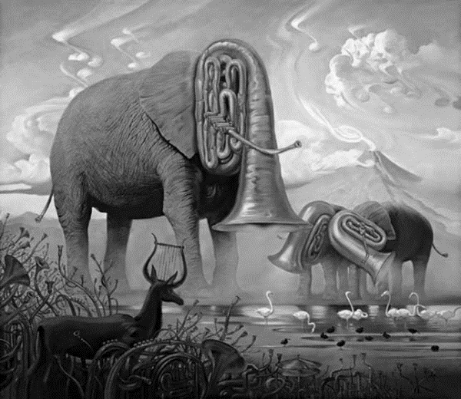

Bill Robinson