### A Little Poem

### for Concert Band

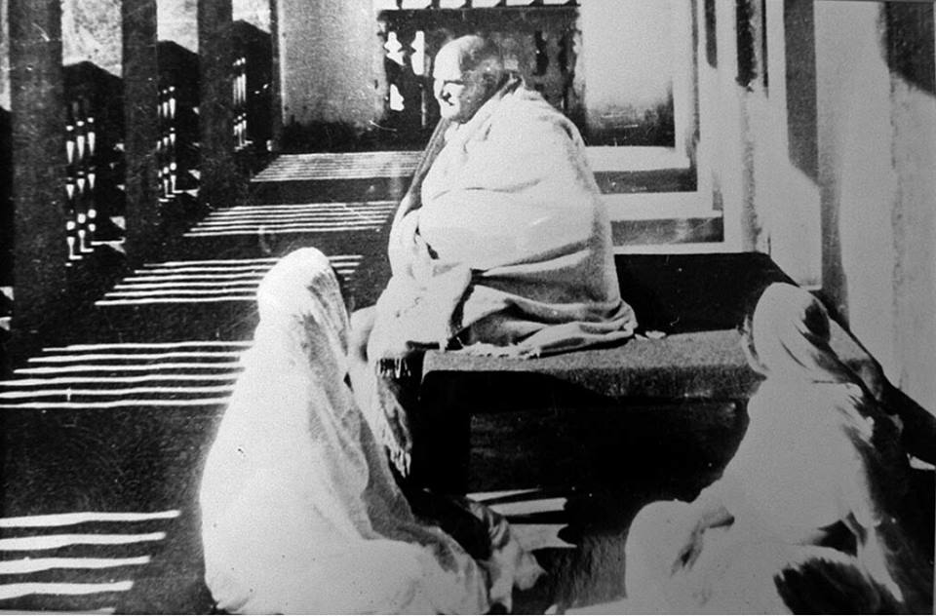

Bill Robinson